1) Write a query that counts all orders for October 3

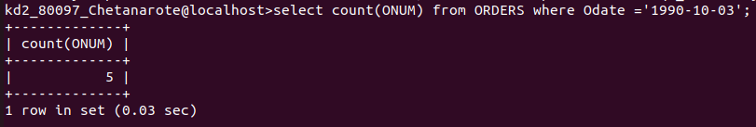
2) Write a query that counts all the number of different non-Null city values in the CUSTOMERS table

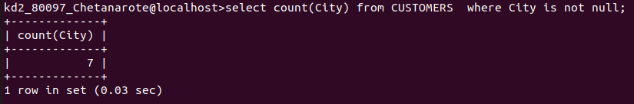
3) Write a query that selects each customer’s smallest order

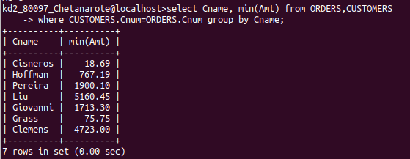

4)Write a Query that selects the first customer in alphabetical order , whose names begins with G

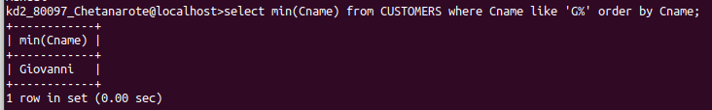

5) Write a query that selects the highest rating in each city

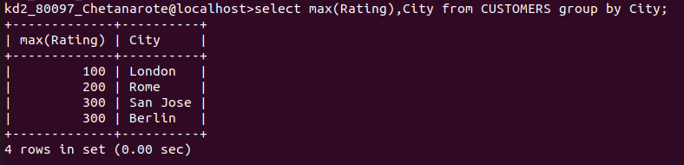
6) Wrote a query that counts the number of salespeople registering orders for each day. (If a salesperson has more than one order on a given day, he or she should be counted as one.

